NEPAL COLLEGE OF INFORMATION TECHNOLOGY
Balkumari, Lalitpur
Affiliated to Pokhara University

LAB REPORT FOR DATABASE MANAGEMENT SYSTEM


LAB REPORT 9: FAMILIARIZATION WITH AGGREGATE FUNCTIONS

Submitted by: Submitted to:
Name: Arpan Adhikari Er. Simanta Kasaju
Roll No.: 231309
BE-CE (3rd SEM)

S. N | LAB TOPIC | DATE | REMARKS
1. | INTRODUCTION TO SQL | 10th Nov
2. | FAMILIARIZATION WITH DDL COMMAND | 17th Nov
3. | FAMILIARIZATION WITH VARIOUS CONSTRAINTS IN SQL | 24th Nov
4. | FAMILIARIZATION WITH DML COMMANDS (INSERT, UPDATE, DELETE) | 1st Dec
5. | FAMILIARIZATION WITH DCL COMMANDS (GRANT, REVOKE) | 8th Dec
6,7. | FAMILIARIZATION WITH TCL COMMAND AND DQL COMMANDS | 30th Dec
8. | FAMILIARIZATION WITH SOME CLAUSES (SELECT, FROM, WHERE, GROUP BY, HAVING, ORDER BY,BETWEEN, NOT BETWEEN), ALIAS OPERATION (AS OPERATOR), CASE, NESTED QUERY COMMANDS (IN, NOT IN, HAVING, ALL, ANY, EXIST), Union. | 30th Dec
9. | FAMILIARIZATION WITH AGGRIGATE FUNCTION AND AGGRIGATE FUNCTION WITH GROUP BY AND HAVING | 29th Jan

THEORY:
Aggregate Functions
Aggregate functions are used in SQL to perform calculations on a set of values, resulting in a single summary value. These functions are often used to compute statistical values from a database table. They operate on a column of data and return a single value, such as a sum, average, count, minimum, or maximum. Aggregate functions are essential in data analysis and reporting, allowing users to derive meaningful insights from large datasets.
The most commonly used aggregate functions include:
- SUM(): Calculates the total of numeric values in a column.
- AVG(): Computes the average of numeric values.
- COUNT(): Counts the number of rows or non-null values in a column.
- MIN(): Finds the smallest value in a column.
- MAX(): Finds the largest value in a column.
Example Usage
SELECT SUM(salary) AS TotalSalary FROM employees;
SELECT AVG(age) AS AverageAge FROM students;
SELECT COUNT(*) AS TotalRows FROM orders;
SELECT MIN(price) AS LowestPrice FROM products;
SELECT MAX(score) AS HighestScore FROM results;

Aggregate Functions with GROUP BY
The GROUP BY clause is used with aggregate functions to group rows that have the same values in specified columns into summary rows. Each group is processed individually by the aggregate function, producing a result for each group.
Syntax
SELECT column_name, AGGREGATE_FUNCTION(column_name)
FROM table_name
GROUP BY column_name;
Example Usage
Consider a table named sales with columns product, region, and amount.
SELECT region, SUM(amount) AS TotalSales
FROM sales
GROUP BY region;
This query calculates the total sales for each region by grouping rows based on the region column.

Aggregate Functions with GROUP BY and HAVING
The HAVING clause is used to filter groups based on conditions applied to aggregate functions. Unlike the WHERE clause, which filters individual rows before grouping, the HAVING clause filters groups after aggregation.
Syntax
SELECT column_name, AGGREGATE_FUNCTION(column_name)
FROM table_name
GROUP BY column_name
HAVING condition;
Example Usage
SELECT region, SUM(amount) AS TotalSales
FROM sales
GROUP BY region
HAVING SUM(amount) > 10000;
This query calculates the total sales for each region and then filters the results to include only regions where the total sales exceed 10,000.

Key Points to Remember
- Aggregate functions are used to summarize data and return single values.
- The GROUP BY clause organizes data into groups based on specified columns.
- The HAVING clause applies conditions to groups, unlike WHERE, which applies to rows.
- Aggregate functions combined with GROUP BY and HAVING are powerful tools for analyzing and reporting data effectively.

Questions:

1.create the table:
Syntax:
CREATE TABLE student_data (
id INT PRIMARY KEY,
name VARCHAR(50),
address VARCHAR(50),
marks INT,
gender VARCHAR(10),
faculty VARCHAR(50)
);
INSERT INTO student_data (id, name, address, marks, gender, faculty) VALUES
(1, 'ram', 'ktm', 80, 'male', 'computer'),
(2, 'ram', 'pkr', 90, 'male', 'civil'),
(3, 'hari', 'chitwan', 70, 'male', 'computer'),
(4, 'sita', 'ktm', 50, 'female', 'computer'),
(5, 'Shila', 'Patan', 90, 'Female', 'BCA'),
(6, 'shiva', 'ktm', 80, 'male', 'BCA'),
(7, 'Sita', 'Bkt', 70, 'Female', 'BCA'),
(8, 'Arif', 'Bkt', 80, 'male', 'Civil'),
(9, 'Rochana', 'Patan', 85, 'Female', 'Architecture'),
(10, 'alpija', 'ktm', 90, 'Female', 'Architecture');
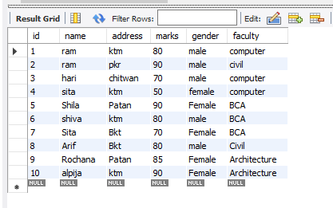

2.Find the aggregate of marks:
Syntax:
SELECT SUM(marks) AS total_marks FROM student_data;
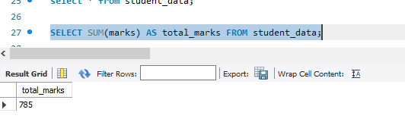

3. Find the maximum score in the overall faculty:
Syntax:
SELECT MAX(marks) AS max_marks, faculty FROM student_data GROUP BY faculty;
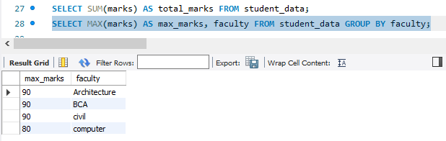

4. Find the maximum score in the computer faculty;
SELECT MAX(marks) AS max_marks FROM student_data WHERE faculty = 'computer';
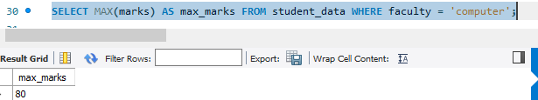

5. Find the top 3 students:
SELECT * FROM student_data ORDER BY marks DESC LIMIT 3;
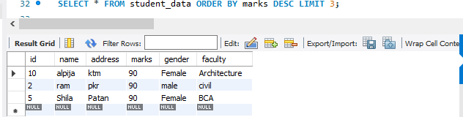

6. Find the last 3 students:
SELECT * FROM student_data ORDER BY marks ASC LIMIT 3;
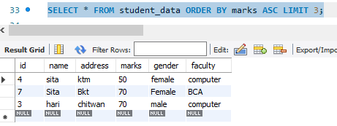

7. Select all addresses in uppercase:
SELECT UPPER(address) AS address_uppercase FROM student_data;
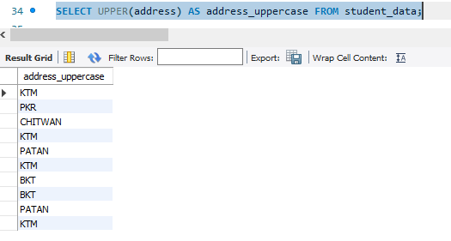

8. Count no. of students who score > 80:
SELECT COUNT(*) AS students_above_80 FROM student_data WHERE marks > 80;
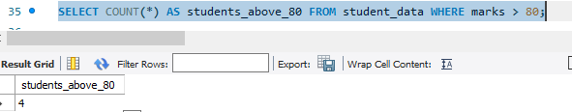

9. Count the number of students with their marks without any repetition (distinct):
SELECT COUNT(DISTINCT marks) AS distinct_marks_count FROM student_data;
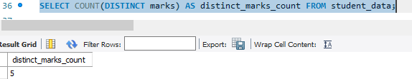

10. Count the number of faculty available (distinct):
SELECT COUNT(DISTINCT faculty) AS distinct_faculty_count FROM student_data;
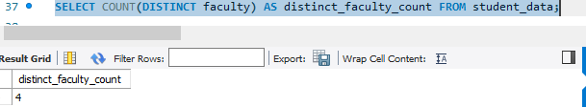

11. Count the number of students whose name starts with 'S':
SELECT COUNT(*) AS students_start_with_S FROM student_data WHERE name LIKE 'S%';
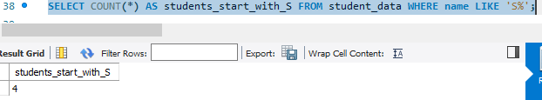

12. Count the number of students from KTM only:
SELECT COUNT(*) AS students_from_ktm FROM student_data WHERE address = 'ktm'; 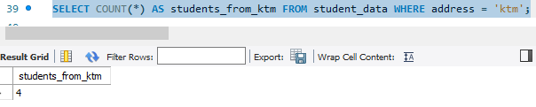

13. Count the number of students by address:
SELECT address, COUNT(*) AS students_count FROM student_data GROUP BY address; 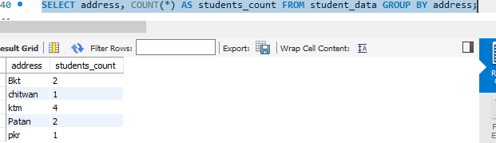

14. Find the name of the student who has the highest marks:
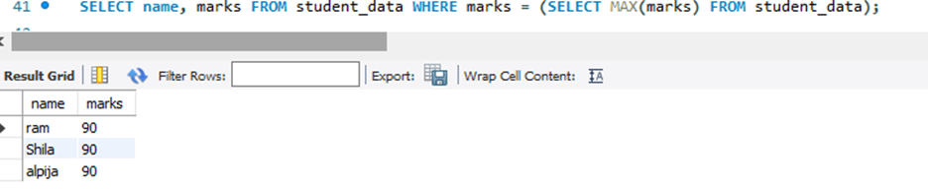

15. Find the name of the student who has the lowest marks:
SELECT name, marks FROM student_data WHERE marks = (SELECT MIN(marks) FROM student_data);
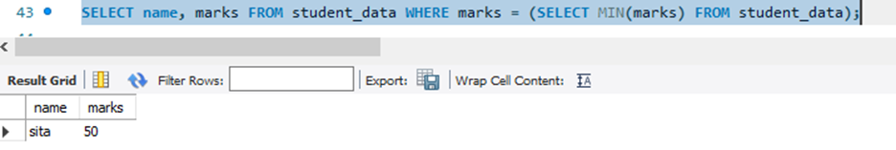

16. Find the gender of the student who has the highest marks:
SELECT gender FROM student_data WHERE marks = (SELECT MAX(marks) FROM student_data);
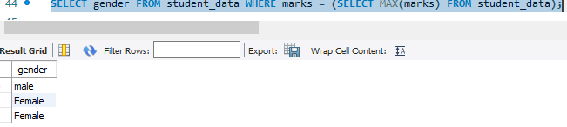

17. Find the gender of the student who has the lowest marks:

SELECT gender FROM student_data WHERE marks = (SELECT MIN(marks) FROM student_data);
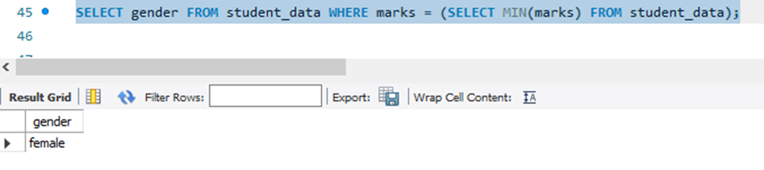

18. How many students are there in all faculty?

SELECT faculty, COUNT(*) AS students_count FROM student_data GROUP BY faculty;

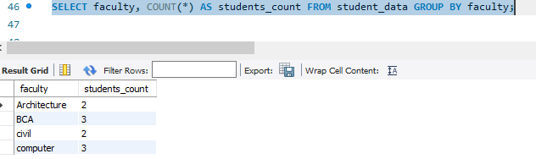

19. How many students are there in the computer faculty only?

SELECT COUNT(*) AS students_in_computer FROM student_data WHERE faculty = 'computer';

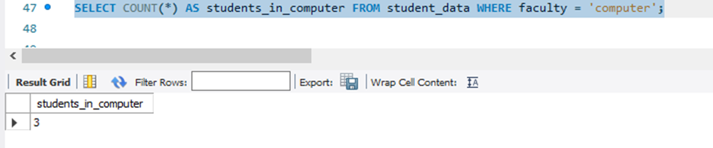

20. Find the total sum of marks in BCA faculty only:

SELECT SUM(marks) AS total_bca_marks FROM student_data WHERE faculty = 'BCA';

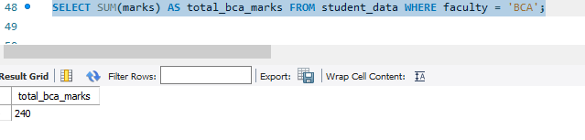

21. Find the total sum of marks of every faculty:

SELECT faculty, SUM(marks) AS total_marks FROM student_data GROUP BY faculty;

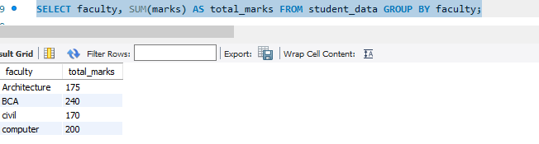

22, Find the total sum of marks of each faculty where the aggregate sum > 200:

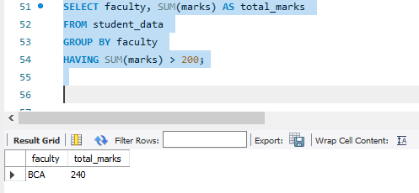

23. Find the 2nd highest marks:

SELECT MAX(marks) AS second_highest_marks

FROM student_data

WHERE marks < (SELECT MAX(marks) FROM student_data);

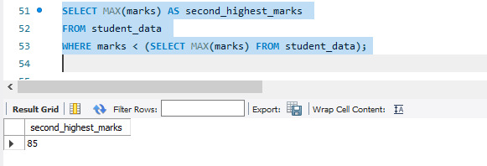

24. Find the highest marks faculty-wise:

SELECT faculty, MAX(marks) AS highest_marks FROM student_data GROUP BY faculty; 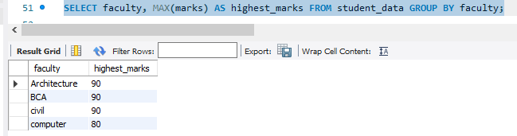

25.. Show the faculty whose aggregate sum is > 200:

SELECT faculty, SUM(marks) AS total_marks

FROM student_data

GROUP BY faculty

HAVING SUM(marks) > 200;

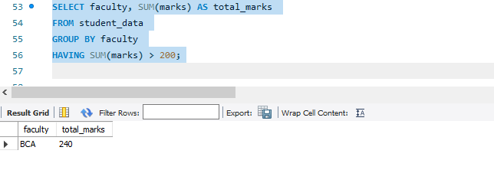26. Find the lowest marks faculty-wise:

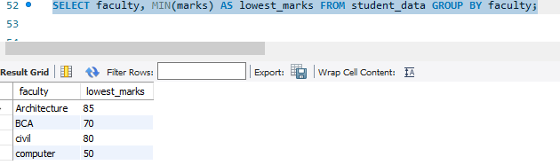

CONCLUSION:
Aggregate functions, along with the GROUP BY and HAVING clauses, are essential components of SQL for data analysis and reporting. They allow users to summarize large datasets by performing calculations like total, average, minimum, maximum, and count.
The GROUP BY clause organizes data into meaningful groups, enabling grouped analysis, while the HAVING clause filters groups based on specified conditions. Together, these tools make SQL highly effective for deriving insights and producing detailed, summarized reports from raw data.
By mastering these concepts, database users can efficiently process and analyze complex datasets, making informed decisions based on the summarized results.

